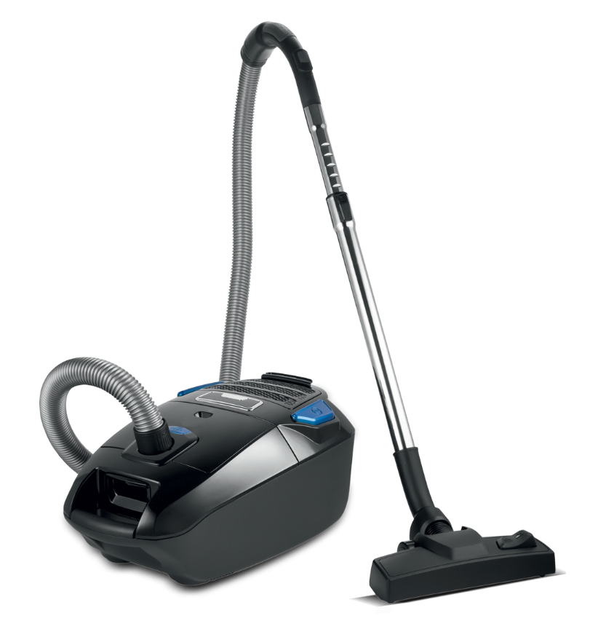
Dawlance Vacuum Cleaner
Rs.34,500
Dawlance vacuum cleaner is designed for practical everyday cleaning with strong suction, easy movement, and home-friendly maintenance for busy households.

Specifications
- Type: Vacuum Cleaner
- Use: Everyday cleaning
- Mobility: Portable body
- Focus: Floor and corner cleaning

Key Features
- Strong suction
- Portable design
- Dust collection support
- Easy home use

